**Phishing Domain Detection (Classification [Machine Learning]).**

**Wire-Frame**

**Project Member: Aman Gupta.**

This is the home page of the project.

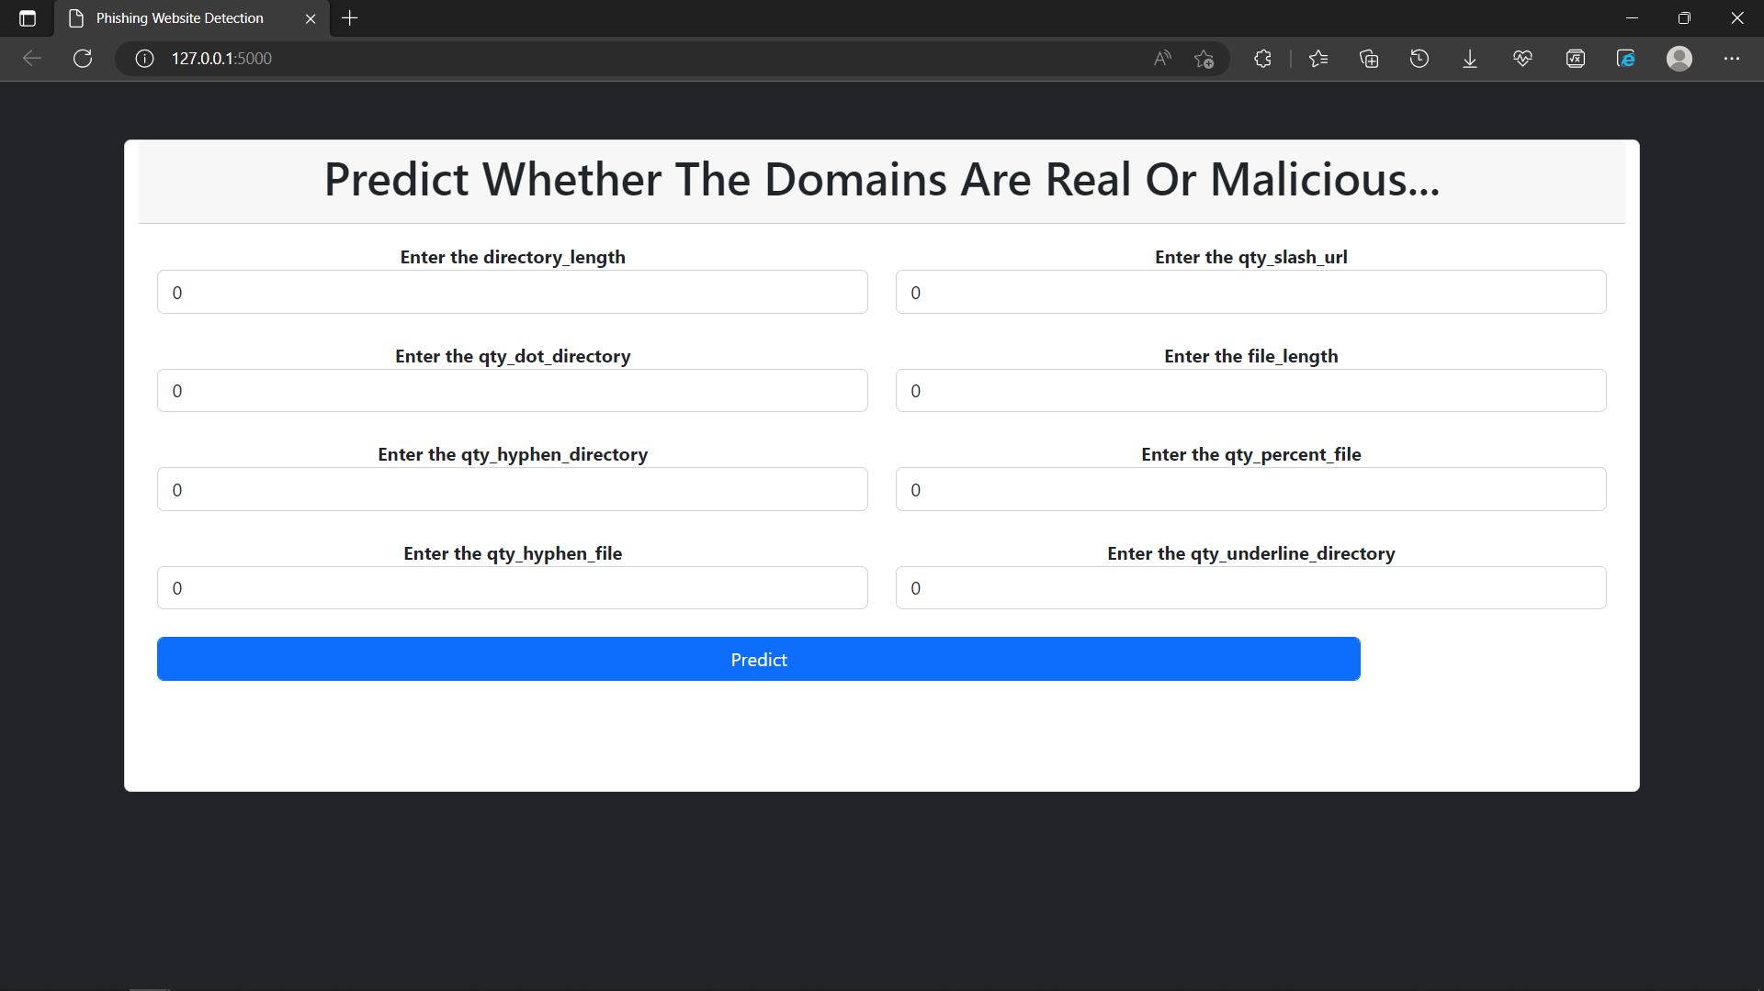In this page user needs to fill all the details of that domain name to check if that domain is fake or real. After filling the details user needs to hit the predict button to get the prediction.

* The prediction part will also be shown on the same page.

The range of the attributes is from -1 to some positive number.

* User can train the model by hitting /train route it will take some time to train the model.

This is the End of Wireframe. Thank you.